High School Academics
Homework Philosophy: The purpose of homework is to develop within the student the importance of good study habits and to accomplish assignments independently as well as the development of student responsibility and initiative. Parents are encouraged to help the student in this regard. The amount of homework assigned will be at the teacher’s discretion.

Grading Scale

A  B  C  D  F | 93-100  85-92  77-84  70-76  69 and below | Superior  Above average  Average  Below average  Failing

Graduation Requirements

CREDIT | SUBJECT
4 | Bible
4 | English
3 | Mathematics
3 | Science
3 | Social Studies
2 | Foreign Language
1 | Physical Education
4 | Electives
Total: 24 Credits

English Language Policy
The curriculum is taught in the English language. In order to maintain high academic standards, the English language will be spoken at all times on the school grounds and at all school activities. Since the teachers and many students at SCS are native English speakers and do not speak Korean, it is rude to speak in any language other than English. Exceptions will be made in language classes or in cases where a student does not yet know English.

Which direction will you take?


Seoul Christian School
KGFA Building 902-4 Eunchon-dong Kwanak-ku Seoul, 151-843, Korea

Tel. 876-3969 Fax 876-3989
http://www.seoulchristianschool.org
kgfa@gfamissions.org
Seoul Christian School
Call 876-3969/3979

Home of the Seoul Christian School Navigators
est. 1998
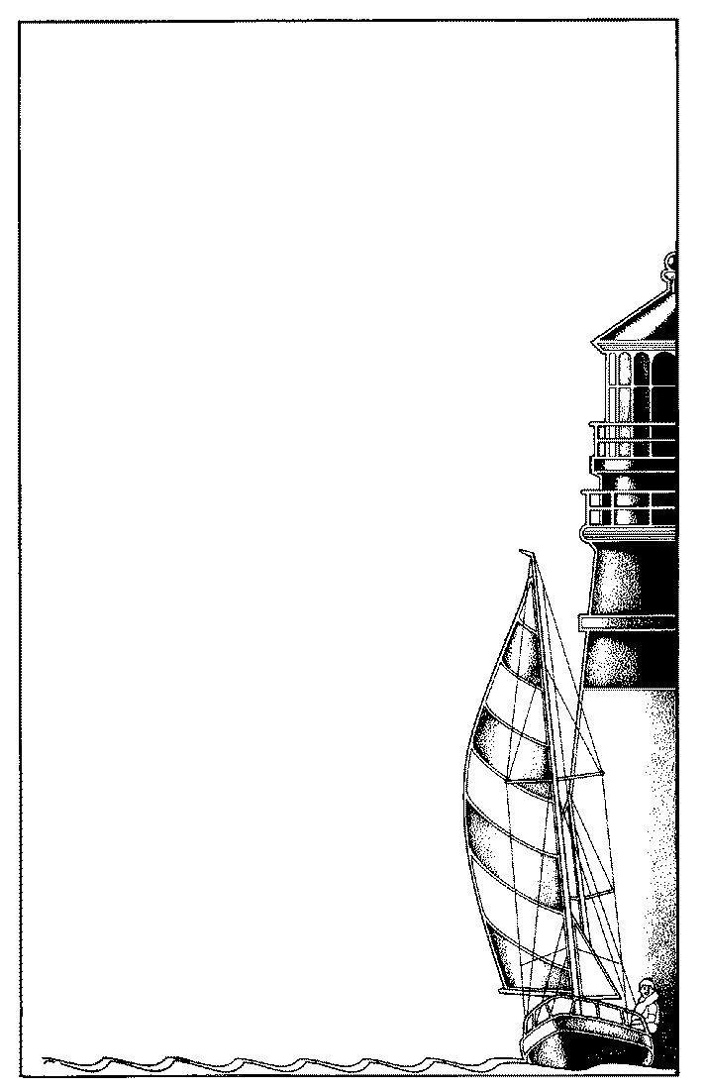

Seoul
CHRISTIAN

SCHOOL

A Guiding Light for the

Next Generation

Financial Information
- A yearly registration fee is due at the time of registration.
- The tuition may be paid in full at the beginning of the year or in quarterly payments. The first payment is due before the first day of classes. All others are due by the date on the financial insert. There is a 5-day grace period after which a 5% late fee will be assessed.
- 30% of the tuition payment is to be paid in U.S. dollars. The remaining 70% is to be paid in Korean Won through Kookmin bank.

Admissions requirements
Students entering K-5 must be five years of age by September1 of that year. Students entering first grade must be six years of age by September 1 of that year.
The following documents are required for registration:
1. Completed registration form with two photos.
2. Transcripts (in English) from the last school attended.
3. Each enrolling student will be given a placement test to determine his grade level.
4. Interview with principal.
All classes have an enrollment limit. Students are accepted in order of their registration. Returning students are given priority enrollment before May 1. After the limit is reached, other students will be placed on a waiting list. The school year runs from September to June.

Attendance and Withdrawal
- School hours are from 8:45 a.m. to 3:45 p.m.
- Supervision of elementary children is provided from 8:30 a.m. to 3:40 p.m. Monday through Friday. Parents who bring their elementary children before 8:30 a.m. must supervise them until opening time.
- Absences are permitted only in cases of illness or an emergency. All other cases must be approved by the principal.
- If a student is absent, the parents should call and inform the school of this absence. A note of explanation must be presented to the office upon the student’s return.
- If the absence is planned, permission should be obtained in advance. Students should schedule doctor and dental appointments other than at school times.
- Students are not permitted to leave the school premises during regular school hours without authorization.
- Notice of early withdrawal must be made at least two
weeks in advance. All books and school property must
be returned and finances cleared before records can be
released.

Standard of Conduct
The Christian should do all things for the glory of God by maintaining a Christian standard in courtesy, kindness, morality and honesty and avoid worldly practices which will result in a decline in his physical, mental and spiritual welfare. In order to provide the right kind of environment, SCS has set forth the following standard of conduct to be observed at all times:
- Complaining is not tolerated since it is destructive to the spirit and harmony of the school and indicates a lack of submission. If there are complaints and disagreements they should be discussed privately with the administration.
- Any student who is found to have cheated will be disciplined. The same penalty applies to a student who helps another student to cheat.
- Gum chewing is not allowed while in school.
- Students may not listen to rock music. MP3 players may not contain rock music and must be kept in the student’s locker during school hours. Any videos brought to school must be previewed by the principal or teacher in charge before it may be shown to the students.
- Students cannot use cell phones during school hours, therefore, all cell phones will be kept in the school office until after school.
The following offences will result either in dismissal or suspension, depending on the gravity of the offense:
- WILLFUL DISOBEDIENCE: This involves a refusal to obey the directive of the teachers or principal, displaying a lack of cooperation or manifesting an attitude of insubordination.
- INSOLENCE: This refers to insulting, disrespectful behavior and includes talking back to a teacher or staff member, using foul language or profanity.
- STEALING: Taking school property or things belonging to another student, such as lunch, books, money or personal possessions.
- VANDALISM: Any student who damages, defaces or destroys school property or that of another student well be disciplined accordingly and will be required to pay for the damages.
- FIGHTING: This indicates a total lack of control of one’s emotions and respect for a fellow human being and will not be tolerated.
- SMOKING, ALCOHOLIC BEVERAGES AND DRUGS: Any student who is in possession of or uses tobacco, alcohol or illegal drugs will be expelled.

After School Activities
- The student’s primary responsibility is to study for their classes at Seoul Christian School.
- Students should not attend after school hakwons except for the following exceptions:
Music lessons, TaeKwonDo or other sport, Math.
- SCS considers it unethical for a student receiving a discounted tuition to also attend after school hakwons.
- Any student receiving a discounted tuition who is also attending after school hakwons will be charged their full tuition fee.

Dress Code
UNIFORMS: There is a direct correlation between student behavior and their appearance. In order to provide an atmosphere conductive to leaning and honoring to God, SCS requires students to wear uniforms. Information concerning their purchase is available at the school office.
BOYS: Hair must be cut in a conventional manner, tapered in the back and off the collar and ears. No undercuts and
No hair dye. Side-burns can be no longer than the middle of the ear. High school students must be clean shaven. GIRLS: Girls must dress modestly. Uniform skirts and jumpers must reach to the bottom of the knee. Only one pierced earring can be worn in each ear.

